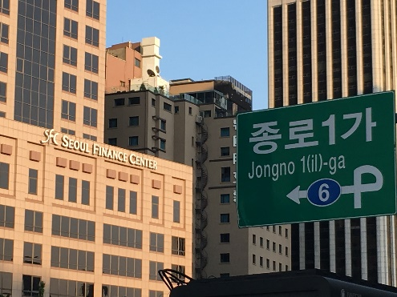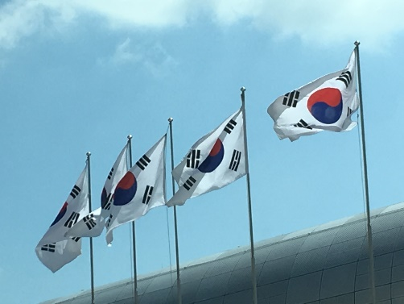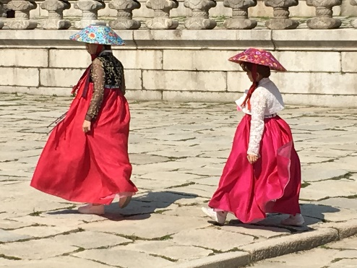

Understanding
KOREA
Past, Present and Future

Themes : territory of disagreements, challenges in Korea-Japan relationship,
hope for peace in East Asia and a journalist’s perspective of North Korea

Mika Mäkeläinen, YLE
Gabriel Jonsson, Stockholm University
Vladimir Tikhonov, University of Oslo
Eun-jeung Lee, Free University Berlin

9 October 2018 at 15:00-18:00
University of Helsinki
Pieni Juhlasali, Fabianinkatu 33

Sponsored by
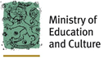

Organised by the University of Helsinki and Finland – Republic of Korea Association

